KO160-1250-3-01FC
电气参数Electronical characteristics
产品型号 Production model | KO160-1250-3-01FC
额定输出功率 Rated output power | AC 1250VA
初级额定电压 Primary Rated voltage | AC 220V
额定频率 Rated ferquency | 50Hz
次级空载电压 Secondary no-load voltage | AC 51.5V-0-51.5V±5% 51.5V-0-51.5V±5% 25.8V-0-25.8V
次级负载电压/电流 Secondary loaded voltage / current | AC 50V-0-50V±5%@6.0A 50V-0-50V±5%@6.0A 25V-0-25V±5%@0.5A
初级空载电流 Primary exciting current | Max. 150mA(初级额定输入电压Primary rated input voltage)
安全标准 Safety standard | GB8898-2011 (CQC )
绝缘等级 Insulation class | Class B (130Deg.C)
接地系统Ground system | Class-II
温升Temperature rise | 85Deg.C Max.(额定输入at reted input)
外施耐压试验Dielectric Withstand Test | AC 4000V 5mA 1 分钟Minute(初级对次级Primary to Secondary)
感应耐压试验Induced withstand voltage test | AC 440V 400Hz 15S(次级Secondary )
绝缘电阻试验Measurement of dry insulation-resistance | 100M OHM @ DC 500V
安装尺寸Installation size | 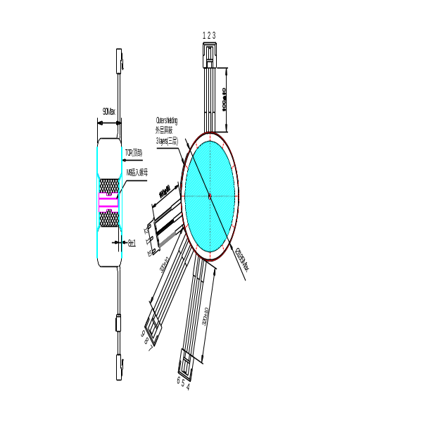

附项选择 additional item
温度保护 Thermal Protector | A4-5A-F 130℃摄氏度温度熔断保险A4-5A-F 130Deg.C Thermal cutoff
短路保护 Short-circuit Protector | 无No，但可根据客户要求增加No,but can increase according to customer’s requirement.
五金配件 Hardware accessories | 橡胶垫Neoprene washer： Φ8.5x150mm 2个  平垫圈Flat washer： M8 2个  弹簧垫圈Spring washer： M8 1个  六角螺丝Hex secews: M8x30mm 2个  插入螺母Insert nut: M8(ODxL=25x68mm) 1个
静电屏蔽 Electronic shielding | 无No，但可根据客户要求增加No,but can increase according to customer’s requirement.
电磁屏蔽 Magnetic shielding | 有Yes.
中心孔灌环氧树脂 Filled epoxy resin | 有Yes.

